Kevin Keating
Kkeating3@ivytech.edu
PhysicsII-(PHYS102-11R-B1-201320)

Experiment: Bohr’s Theory of the Hydrogen Atom
Introduction:
In 1913, the Danish physicist Niels Bohr (1885 - 1962) managed to explain the spectrum of atomic hydrogen by an extension of Rutherford's description of the atom. In that model, the negatively charged electrons revolve about the positively charged atomic nucleus because of the attractive electrostatic force according to Coulomb's law.
But the electron can be taken not only as a particle, but also as a de Broglie wave (wave of matter) which interferes with itself. The orbit is only stable, if it meets the condition for a standing wave: The circumference must be an integer multiple of the wavelength. The consequence is that only special values of radius and energy are allowed. The mathematical appendix explains how to calculate these values.
According to classical electrodynamics, a charge, which is subject to centripetal acceleration on a circular orbit, should continuously radiate electromagnetic waves. Thus, because of the loss of energy, the electron should spiral into the nucleus very soon. By contrast, an electron in Bohr's model emits no energy, as long as its energy has one of the above-mentioned values. However, an electron which is not in the lowest energy level (n = 1), can make a spontaneous change to a lower state and thereby emit the energy difference in the form of a photon (particle of light). By calculating the wavelengths of the corresponding electromagnetic waves, one will get the same results as by measuring the lines of the hydrogen spectrum.
You must not take the idea of electrons, orbiting around the atomic nucleus, for reality. Bohr's model of the hydrogen atom was only an intermediate step on the way to a precise theory of the atomic structure, which was made possible by quantum mechanics and quantum electrodynamics.
Procedure:
- Load up the Java Lab from the web site shown above. This applet illustrates a hydrogen atom according to particle or wave model.

- Choose a principal quantum number starting with n = 1, and choosing at least three other values. The right part of the graphics represents the energy levels of the atom. Right down at the bottom you can read off the orbital radius r and the total energy E.

- Try to vary the orbit's radius with pressed mouse button. This will generally lead to a non-stationary state. You can realize that by using the option "Wave Model". The green wavy line which symbolizes the de Broglie wave will not be closed in most cases. Only if the circle's circumference is an integer multiple of the wavelength (blue), you will get a stationary state.

- Plot a graph of the radius vs. quantum number, and a graph of the energy (in eV) vs. the quantum number. (The quantum number of both graphs should be on the x-axis.)

- For each value of n, sketch the shape of the non-stationary state when the “Wave Model” option is used. Move the orbit in and out to several (at least three) locations to examine these results.

- Using your text or other source, explain what you are observing.

Data and Observations:
Using the equation for the following quantum numbers yields the calculated eVolts
E_{n} =$\frac{-13.6 eV}{n^{2}}$
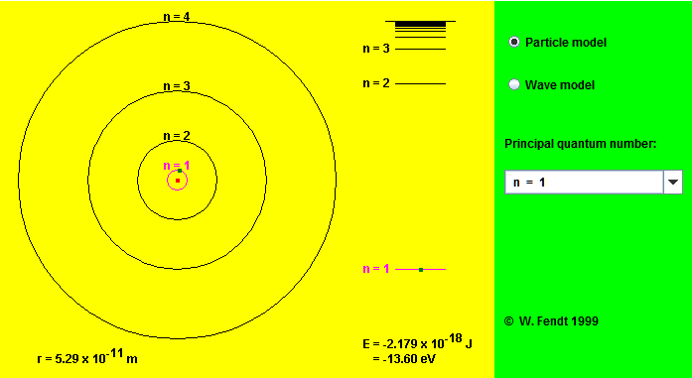
Particle model with orbit at n=1
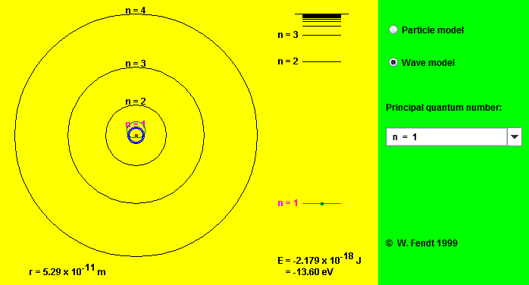
Wave model with orbit @ n=1 (red is particle orbit, green symbolizes de Broglie wave)

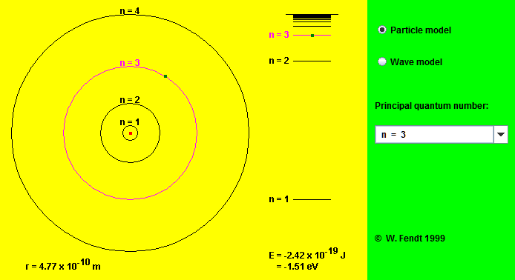
Particle model with orbit at n=3
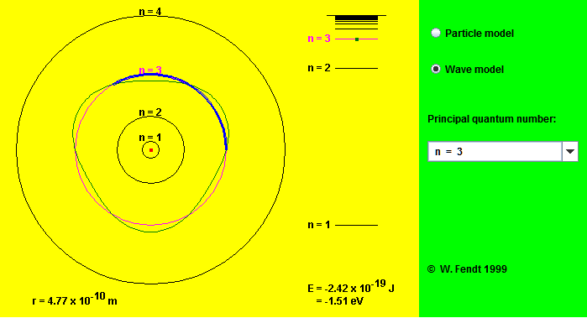
Wave model with orbit @ n=3 (red is particle orbit, green symbolizes de Broglie wave)

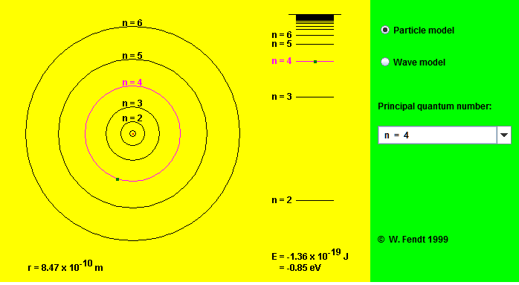
Particle model with orbit at n=4
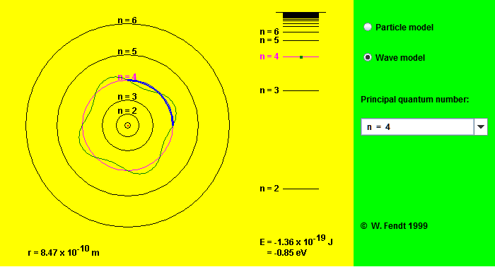
Wave model with orbit @ n=4 (red is particle orbit, green symbolizes de Broglie wave)

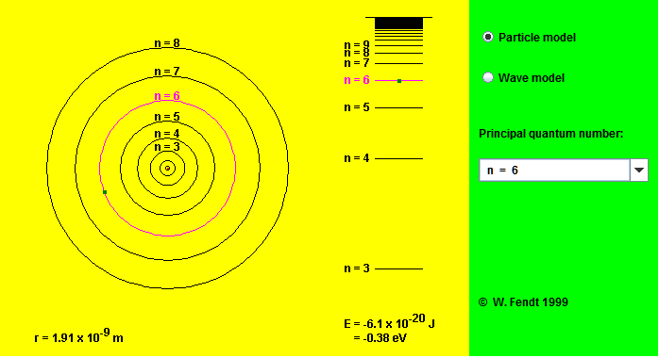
Particle model with orbit at n=6
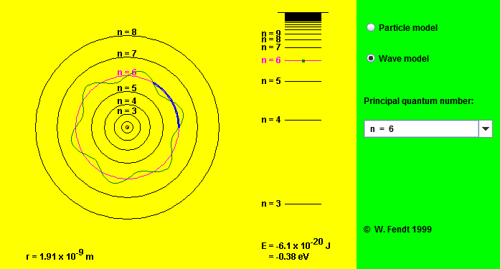
Wave model with orbit n=4 (red is particle orbit, green symbolizes de Broglie wave)

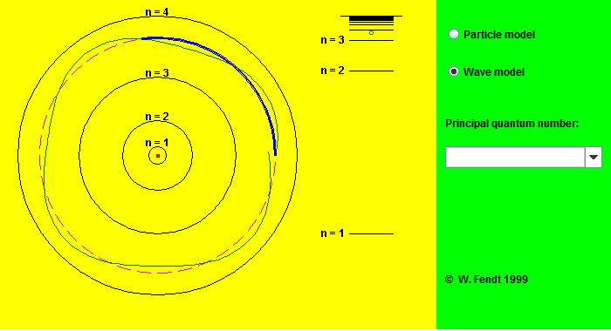
Wave model with orbit between n=3 and n=4 (red is particle orbit, green symbolizes de Broglie wave)

Conclusions:
As both the calculations show and the graphs visually demonstrate the closer the electron’s orbit (the smaller the radius) is to the nucleus the less energy is present.
In addition the more excited the electron the more energy it has as it moves to the outer orbits demonstrated by the increasing quantum number.

Submitted: Dec 2, 2013 4:01 PM

