Kevin Keating
Kkeating3@ivytech.edu
PhysicsII-(PHYS102-11R-B1-201320)

Experiment: Radioactive Decay
Introduction:
The law of radioactive decay predicts how the number of the not decayed nuclei of a given radioactive substance decreases in the course of time. The red circles of this simulation symbolize 1000 atomic nuclei of a radioactive substance whose half-life period (T) amounts to 20 seconds. The diagram in the lower part of the applet represents the fraction of the not yet decayed nuclei (N/N0) at a given time t, predicted by the following law:
N = N₀ • 2^{-t/T}
N is the number of the not decayed nuclei
N₀ is the number of the initially existing nuclei
t is the time
T is the half-life period of the material
Procedure:
1. Load up the Java Lab from the web site:
http://www.walter-fendt.de/ph14e/lawdecay.htm.
2. As soon as the applet is started with the yellow button, the atomic nuclei will begin to "decay" (change of color from red to black). You can stop and continue the simulation by using the button "Pause / Resume". In this case, a blue point for the time and the fraction of the not yet decayed nuclei is drawn into the diagram. (Note that often these points don't lie exactly on the curve!)
3. If you want to restore the initial state, you will have to click on the "Reset" button.
4. Copy or record the data and the graph for at least five half-lives, and submit this data and graph as part of your report.
5. Pick one atom (usually a corner atom is easier to keep track of). Reset the initial state at least six times, and for each time, determine when this atom decays. When the atom decays, pause the process, and then record the number of nuclei “already decayed.” When it decays, you can reset to the next trial.
6. It is possible to give the probability that a single atomic nucleus will "survive" during a given interval. This probability amounts to 50 % for one half-life period. In an interval twice as long (2 T) the nucleus survives only with a 25 % probability (half of 50 %), in an interval of three half-life periods (3 T) only with 12.5 % (half of 25 %), and so on. You can't, however, predict the time at which a given atomic nucleus will decay. For example, even if the probability of a decay within the next second is 99 %, it is nevertheless possible (but highly improbable) that the nucleus decays after millions of years. Finally, show how the data that you obtained either proves or disproves this concept. Explain in detail.
7. Finally, write the report.
Data and Observations:
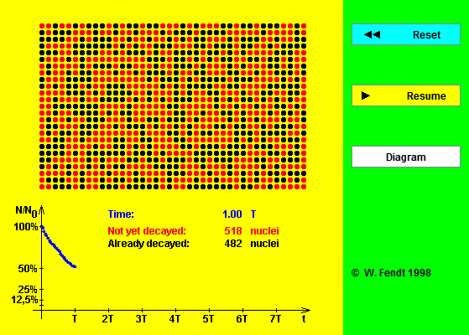
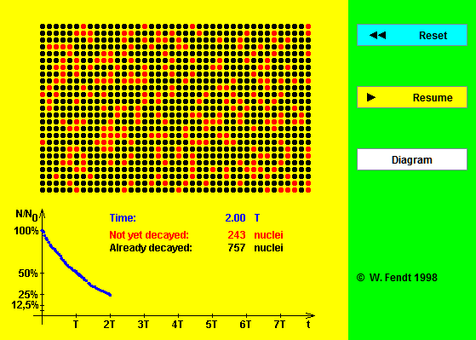
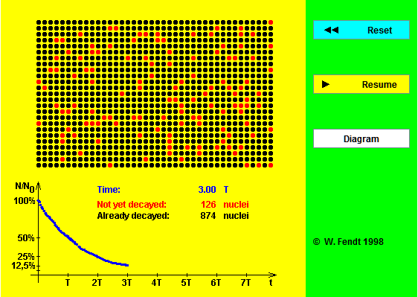

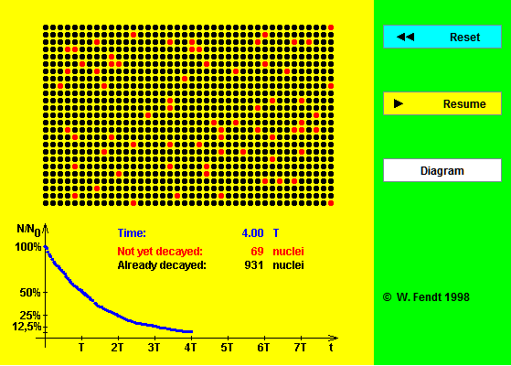
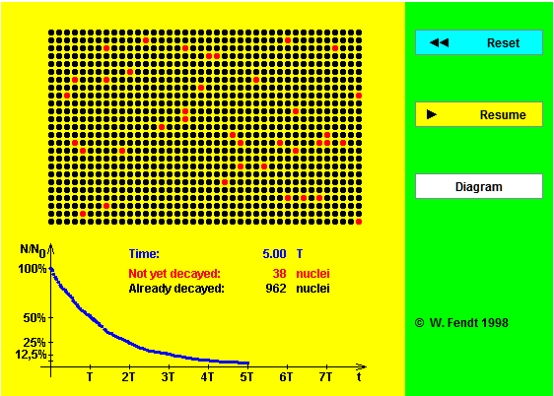
Trial No. | Number of Decayed Nuclei | No. of half-lives | Elapsed Time | % Nuclei Remaining
1 | 764 | 2.07 | 41.4 | 23.60%
2 | 410 | 0.76 | 15.2 | 59.00%
3 | 711 | 1.8 | 36 | 28.90%
4 | 972 | 4.7 | 94 | 2.80%
5 | 281 | 0.47 | 9.4 | 71.90%
6 | 738 | 1.86 | 37.2 | 26.20%
7 | 327 | 0.54 | 10.8 | 67.30%
8 | 748 | 2.07 | 41.4 | 25.20%

Conclusions:
While being able to predict the rate as a percentage at which nuclei in a substance will decay, it is not possible to predict with any specificity when an individual nuclei in a substance will decay.
As demonstrated with the Atom Decay Chart and the data and graphs from the Java Lab above there is not possible to predict the moment in time distinct nuclei will decay. All the data show that while the percentage of decay specific to the elapsed time period is predictable, the decay of an individual nucleus occurs at random times so by definition is unpredictable.

