Kevin Keating
Kkeating3@ivytech.edu
PhysicsII-(PHYS102-11R-B1-201320)

Experiment: Prism: Reflection and Refraction

Introduction:
Light travels through different media at different speeds resulting in reflection and refraction.
The angle of incident for reflected light is equal to the angle of reflection.
For refracted light Snell’s Law can be used to calculate the incident of refraction:
Index of refraction for media 1=n₁; angle of incidence Ɵ₁
Index of refraction for media 1=n₂; angle of incidence Ɵ₂
Snell’s Law: n₁ sin Ɵ₁ = n₂ sin Ɵ₂
Part of the energy is reflected and the rest propagate into the new media. This ratio is dependent on the angle of incidence and the index of refraction.
Procedure:
Using the applet from the website : http://www.phy.ntnu.edu.tw/java/optics/prism_e.html
- Click on the red arrow to change the direction of the light.
- Click on the body of the light source to change its location relative to the prism.
- Click on the body of the prism to change its location relative to the light source.
- Observe the changes in the intensities, the angles of reflection, the angles of refraction as you change the relations of each to the other.
- After observing the random changes keeping all the relations the same change just the index of refraction from 1.5 to 1.0 in increments of 0.1.
- Sketch the light rays for each value.
- Reset the prism’s index of refraction back to 1.5.
- For three different angles of incidence by either changing the shape of the prism or moving the light source around, use a protractor to measure the angle of incidence of the light ray and the corresponding angle of refraction.
- Record the data and compare the results to Snell’s Law.
- List all error sources.

Data and Observations:
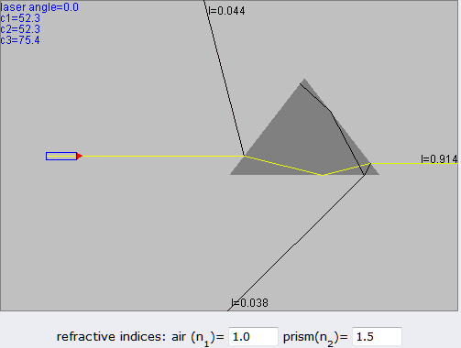
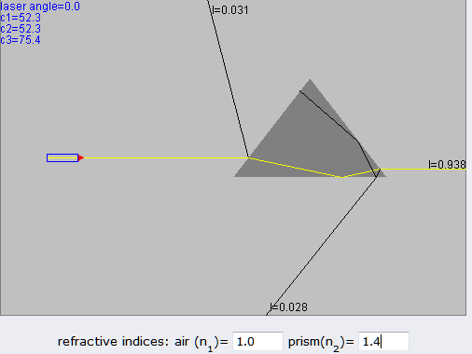
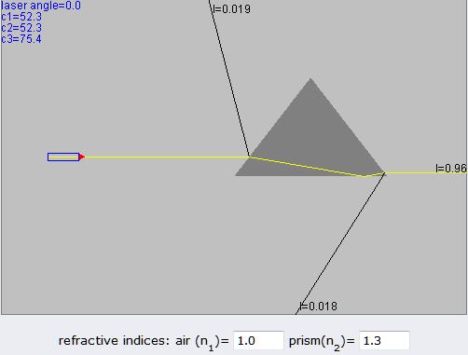
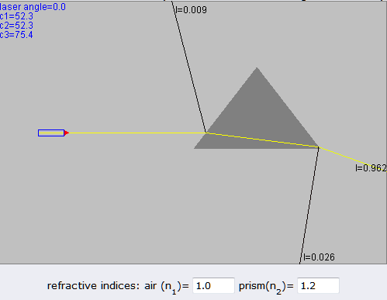
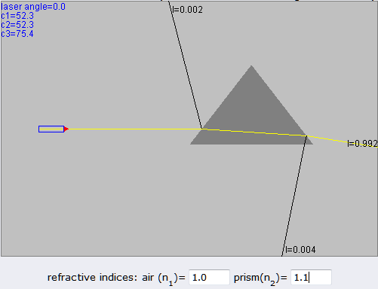
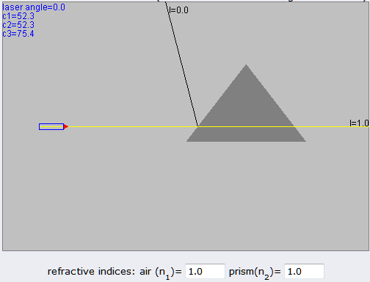

1st light source angle
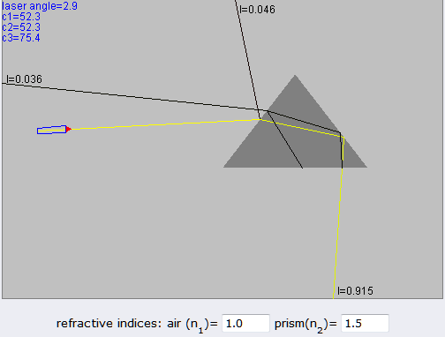
Measured angles:
Angle of incidence= 42ᴼ
Angle of refraction= 27ᴼ
Calculations using Snell’s Law= .6691 ≠ .6809

2nd Light source angle
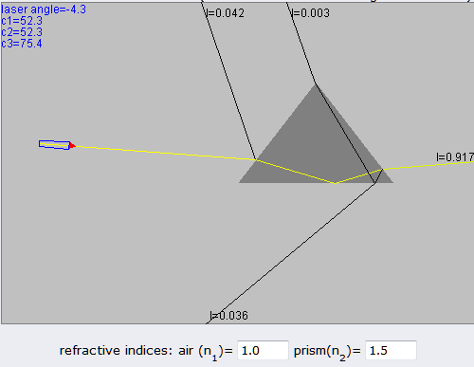
Measured angles:
Angle of incidence= 34ᴼ
Angle of refraction= 21ᴼ
Calculations using Snell’s Law= .5591 ≠ .5375

3rd Light source angle
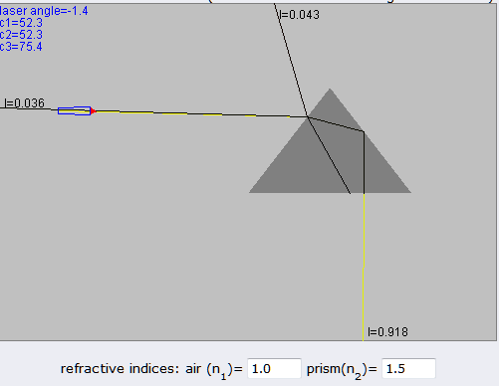
Measured angles:
Angle of incidence= 35ᴼ
Angle of refraction= 23ᴼ
Calculations using Snell’s Law= .5735 ≠ .5860

Possible sources of error include:
Incorrect protractor readings
Printout of the display is not accurate
The small scale of the displayed angles
Inaccuracy in extending lines for protractor measurements

Conclusions:
As the light rays travel from one medium into another the change in the angles of incidence and refraction are determined by the material they are passing through and the size, shape and relationship to the medium. While hand measurements taken from a printout of a computer program give a good indication of angles, for more accuracy a more precise setup with precision instruments would be needed.
In addition, the lower the index of refraction the closer to equal the angle of incidence and the angle of refraction are
.

