Kevin Keating
Kkeating3@ivytech.edu
PhysicsII-(PHYS102-11R-B1-201320)

Experiment: Thin Lenses
Introduction:
The distance an object is from a lens has an effect on the image size and whether it is real or virtual. By changing the distance from the lens the effects it has can be observed.
Procedure:
- Load the Java lab from http://www.phy.ntnu.edu.tw/java/Lens/lens_e.html.
- Select “Lens” for the thin lens effect.
- Press Toggle button to “+” (converging lens).
- Change the value of p from 30 to 5 in decreasing increments of 5.
- Record the location of the image (q) and the type of image (real or virtual) as well as the magnification (M) of the image
- Plot a graph showing the objects position (x axis) versus the image position (y axis).
- Plot a graph showing the objects position (x-axis) versus the magnification (y-axis).
- Repeat Steps 3 through 7 for “-“(diverging lens).
Data and Observations:
Converging Lens
p | q | f | M
30.0 | 15.0 | 10.0 | -0.50
25.0 | 16.6 | 10.0 | -0.66
20.0 | 20.0 | 10.0 | -1.00
15.0 | 30.0 | 10.0 | -2.00
10.0 | ∞ | 10.0 | -100.00
5.0 | -10.0 | 10.0 | 2.00

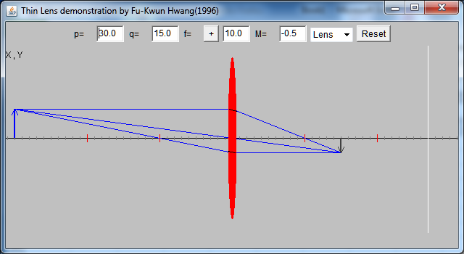
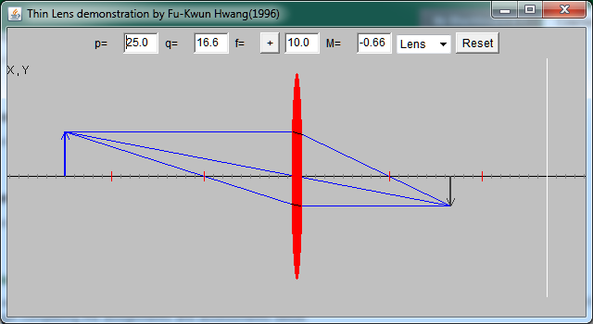
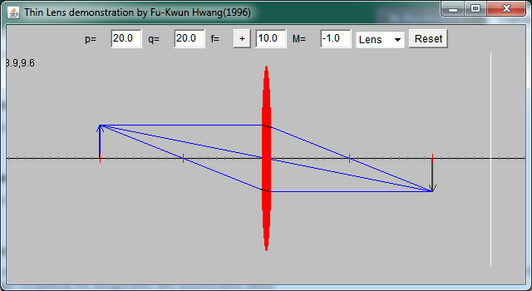
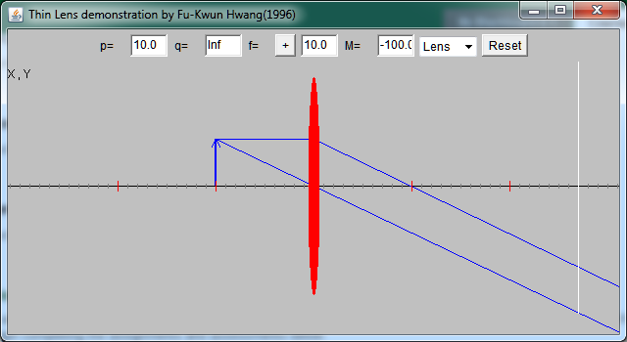
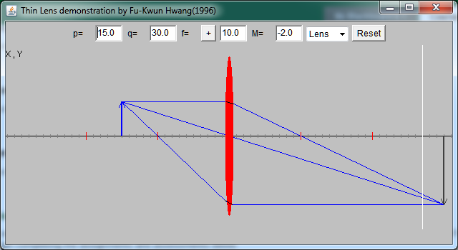
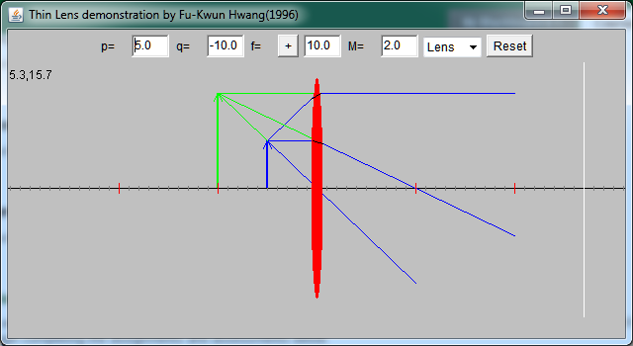
Diverging Lens
p | q | f | M
30.0 | -7.5 | -10.0 | 0.25
25.0 | -7.1 | -10.0 | 0.28
20.0 | -6.6 | -10.0 | 0.33
15.0 | -6.0 | -10.0 | 0.40
10.0 | -5.0 | -10.0 | 0.50
5.0 | -3.3 | -10.0 | 0.66

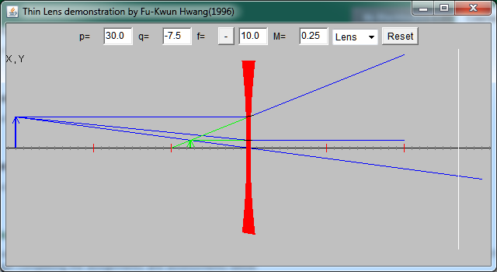
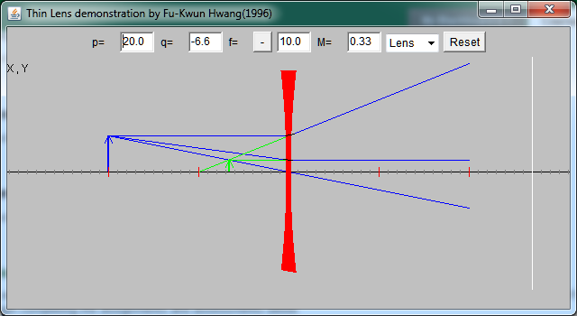
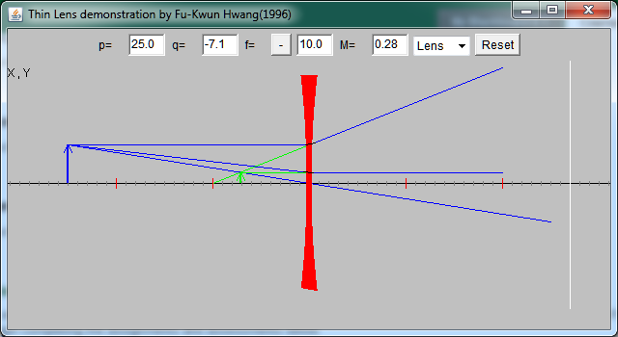
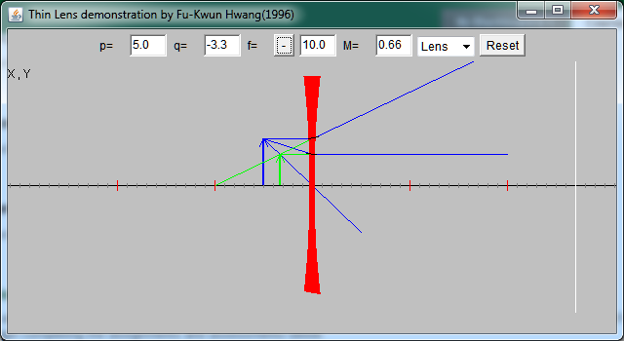
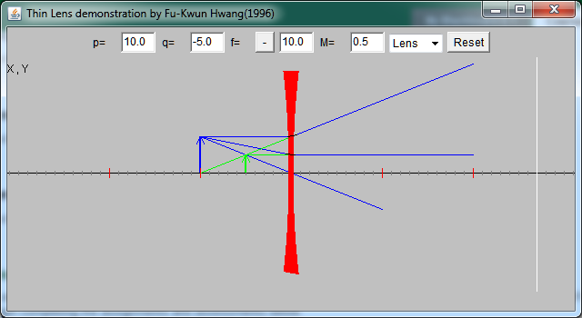
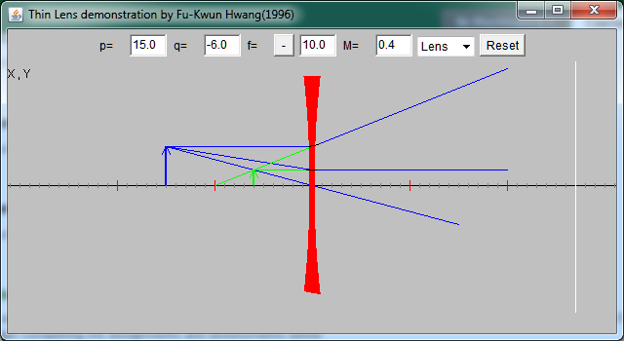

Conclusions:
The closer an object gets to a converging lens the larger the real image is until the focal point of the lens is reached at which point there is no image or a virtual image when the object distance is less than the focal length.
The closer an object get to the diverging lens the larger the virtual image.

