Kevin Keating
Kkeating3@ivytech.edu
PhysicsII-(PHYS102-11R-B1-201320)

Experiment:
Electrical Field and Electrical Potential
Introduction:
Using an applet to setup a distribution of charges and show the electric potential, electric field and equipotential lines. Additionally we can observe the real time interaction of charges.
Procedure:
Load the http://www.cco.caltech.edu/~phys1/java/phys1/EField/EField.html
Place a singe charge of a magnitude -9 to +9 in the field.
Sketch both the equipotential lines and the Electric Field lines by checking the appropriate boxes. Do each separately to determine which is which.
Add a second charge of equal magnitude (and sign) to the right of the first charge.
Repeat step #3 the like charges.
Hit the “Reset” button to clear the screen.
Place three charges of different magnitudes (similar or opposite signs) onto the screen.
Repeat step #3 for these three charges.

Data and Observations:
Single-5 Charge Equipotential Lines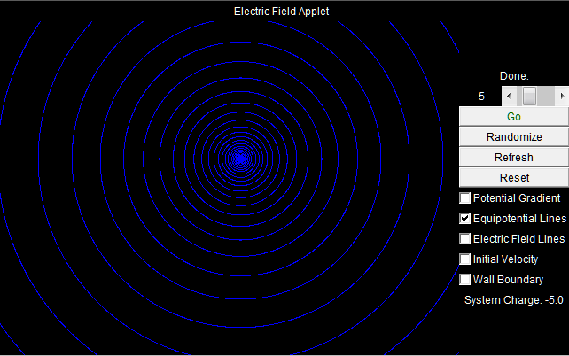
Single -5 Charge Electric Field Lines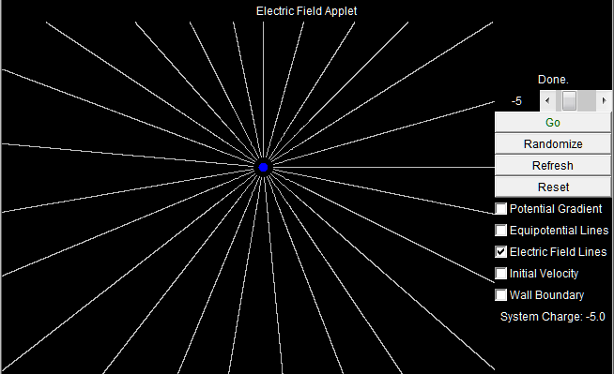
Two -5 charges Equipotential Lines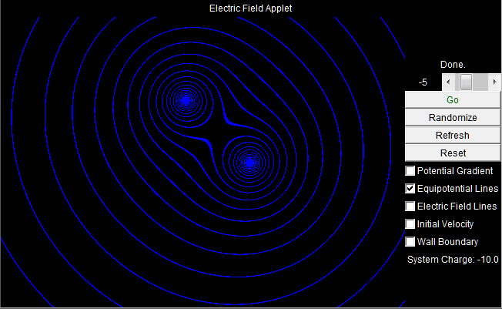
Two -5 charges Electric Field lines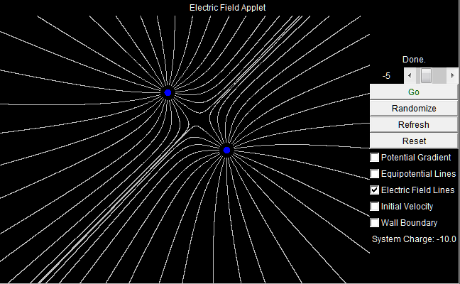
Positive(blue) and negative(red) 5 charges–Equipotential Lines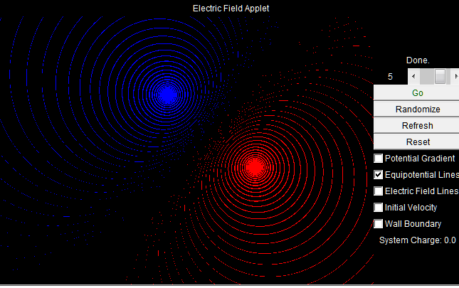
Positive(blue) and negative(red) 5 charges –Electric Field Lines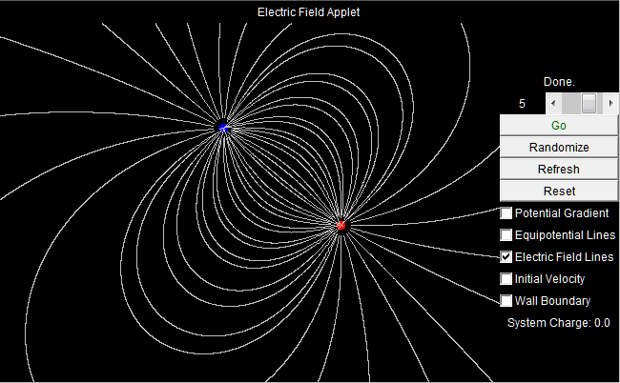
Clockwise +5(red), +1(red) and -4 (blue)Charges Equipotential Lines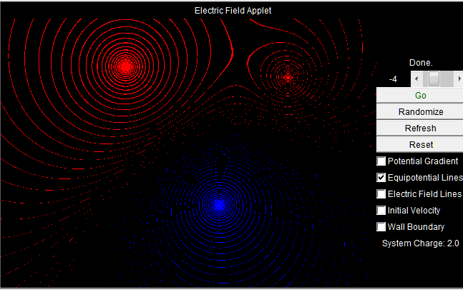
Clockwise +5(red), +1(red) and -4(blue)Charges Electric Field Lines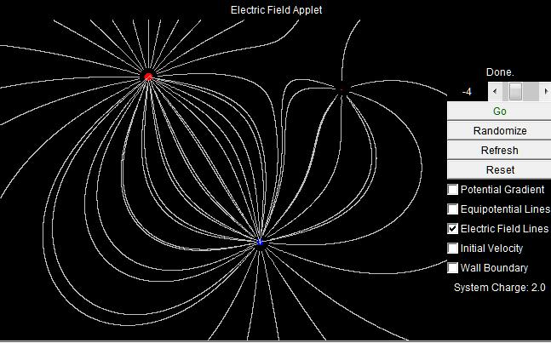
Conclusions:
By observing the Equipotential lines and the Electric Field lines it is possible to see how different charges react to each other.
While observing the equipotential lines it can be observed that they radiate away from the charge much the same way the ripples move away from a single disturbance in a still pond. In addition it can be observed that just as the ripples in a pond are affected by the size and magnitude of other disturbances so are the equipotential lines in the system with more than one charge. Similar charges radiate out away however as they collide and interfere with one another some of the charge dissipates or grows depending upon the sign and magnitude of the charges.
While observing the electric field lines it can be observed that they radiate out much like the rays from a light source, a single charge has a field that radiates out in all directions equally. However, when additional charges are added the electric field lines react according to the magnitude and the sign of the charge. If the charges are similar it can be observed that they repel each other while opposite charges are attracted to each other.

Submission ( September 23, 2013 5:43:27 PM EDT )

