Cantilever Vibration
12/2/2014
Dakota Johnson

Objective: The objective of this experiment is to determine how adding mass affects the resonant frequency of a cantilever beam and how the length of a cantilever beam affects its resonant frequency.
Conclusion: The natural frequency of an object decreases its mass is increased. The natural frequency of an object increases when its length is decreased.
Introduction:
Natural frequency is the frequency that an object will vibrate when disturbed. When mass is added to an object an object the natural frequency should decrease. In the case of the experiment this should be observed when clips are clamped to the end of the stick. Also the natural frequency should increase with decreasing length.
Materials:
- Several sticks of differing lengths, widths, and thicknesses
- 2 Clamps
- Several binder clips
- Stopwatch
- Camera
- Yard sticks
- Board with horizontal stripes
Procedure:
A sample stick was mounted between two yard sticks on the edge of a sturdy table with clamps. The stick’s length, thickness, and width was measured and recorded. A board with stripes was setup on one side of the stick so that the stripes were parallel with the stick. A stopwatch was held next to the board so that a camera could fit the set up and watch within its frame.
1. The stick was pushed down and released. At the same time the stick was released the stopwatch was started. This process was recorded using a camera. The video from the camera was then used to determine the frequency. This was done by counting the number of oscillations within a four second period and then dividing the number of oscillations by the time. This process was then repeated two more time and then the average frequency was calculated. 2. Next a clip was clamped to the end of the stick and the process in step 1 was repeated five times adding a clip after each process. 3. All of the clamps were removed from the stick and the process in step 1 was repeated. 4. The stick was moved so there was a new length hanging off of the table. The new length was measured and recorded. The process in step 1 was then done at this new length. A total of five different lengths were used.
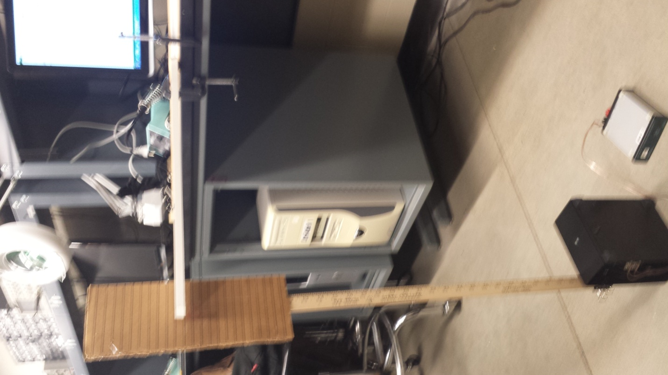
Yard stick
Clamps
Board with Horizontal stripes
Testing stick

Observations:
As more weights were added the oscillations slowed down.
As the length of the stick decreased the oscillations speed up.

Data:
 |  | Weight as Variable
 |  | Initial conditions
 | length | 21.5 | in
 | thickness | 0.5 | in
 | width | 1.125 | in
sample | time | oscillations | Length | Weight | Frequency | Avg Freq
 | sec |  | in | clips | Hz | Hz
1 | 4 | 36 | 21.5 | 0 | 9
2 | 4 | 38 | 21.5 | 0 | 9.5 | 9.5
3 | 4 | 40 | 21.5 | 0 | 10
4 | 4 | 32 | 21.5 | 1 | 8
5 | 4 | 34 | 21.5 | 1 | 8.5 | 8.166667
6 | 4 | 32 | 21.5 | 1 | 8
7 | 4 | 33 | 21.5 | 2 | 8.25
8 | 4 | 33 | 21.5 | 2 | 8.25 | 8.25
9 | 4 | 33 | 21.5 | 2 | 8.25
10 | 4 | 29 | 21.5 | 3 | 7.25
11 | 4 | 28 | 21.5 | 3 | 7 | 7.166667
12 | 4 | 29 | 21.5 | 3 | 7.25
13 | 4 | 26 | 21.5 | 4 | 6.5
14 | 4 | 26 | 21.5 | 4 | 6.5 | 6.583333
15 | 4 | 27 | 21.5 | 4 | 6.75
16 | 4 | 26 | 21.5 | 5 | 6.5
17 | 4 | 26 | 21.5 | 5 | 6.5 | 6.5
18 | 4 | 26 | 21.5 | 5 | 6.5

 |  | Length as Variable
 | length | 21.5 | in
 | thickness | 0.25 | in
 | width | 1.125 | in
sample | time | oscillations | Length | Weight | Frequency | Avg Freq
 | sec |  | in | clamps | Hz | Hz
1 | 4 | 13 | 21.5 | 0 | 3.25
2 | 4 | 13 | 21.5 | 0 | 3.25 | 3.25
3 | 4 | 13 | 21.5 | 0 | 3.25
4 | 4 | 13 | 21 | 0 | 3.25
5 | 4 | 13 | 21 | 0 | 3.25 | 3.25
6 | 4 | 13 | 21 | 0 | 3.25
7 | 4 | 15 | 20 | 0 | 3.75
8 | 4 | 15 | 20 | 0 | 3.75 | 3.75
9 | 4 | 15 | 20 | 0 | 3.75
10 | 4 | 17 | 18 | 0 | 4.25
11 | 4 | 17 | 18 | 0 | 4.25 | 4.25
12 | 4 | 17 | 18 | 0 | 4.25
13 | 4 | 38 | 12 | 0 | 9.5
14 | 4 | 39 | 12 | 0 | 9.75 | 9.583333
15 | 4 | 38 | 12 | 0 | 9.5

Analysis: When the clips were added in the first part of the experiment the frequency calculated decreased with each additional clip. This can be seen in the graph of average frequency vs. weight. The natural frequency calculated when the length of the stick decreased became greater. This can be seen in the graph of average frequency vs. length.

