Forces on a Boom
12/9/2014
Dakota Johnson

Objective: To see if the mathematical evaluations for force in the thread and experimental findings agree.
Conclusion: Mathematical evaluations for force and experimental finding are equivalent.
Introduction: For a system to be in static equilibrium the sum of forces and the sum of the moments equal zero. The system that is set up has four forces acting on it: the force due to gravity, the force from the string, the force from the hanging mass, and the normal force. We also know there are three moments acting on the system: the moment from the string, the moment from the hanging mass and the moment due to gravity. Knowing intuitively that this system is in static equilibrium because it is not moving, we can solve for the tension in the string using the following equation.

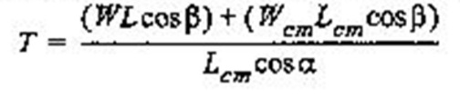
Where T is tension in the string, W is the weight of the balance arm assembly, L is the length of the balance arm assembly, W_{cm} and L_{cm} are the weight of the balance arm assembly at the center of mass and the length of the balance arm assembly at the center of mass respectively. β is the angle between the balance arm and a horizontal line and α is the angle between the string and a line perpendicular to the balance arm.
Materials:
- Statics board
- Mounted spring scale
- Pulleys
- Balance arm
- Thread
- Protractors
- Mass set and hangers
- Pivot
Procedure: On a balance arm that had a ruler on it running from -170mm to 170 mm one protractor was attached at 0mm and the other at 160mm. The pivot was attached at -160mm. This balance arm assembly’s weight was found and recorded. The assembly was attached to the statics board via magnets on the pivot. The spring scale and pulley was mounted above the balance arm assembly. A string was run from the scale around the pulley and tied to the protractor at 0mm. The angles α and β were recorded and the reading on the spring scale was recorded. For the next part of the experiment a hanging mass of 147g was attached to the protractor at 160mm with thread. The angles α and β were recorded and the reading on the spring scale was recorded.
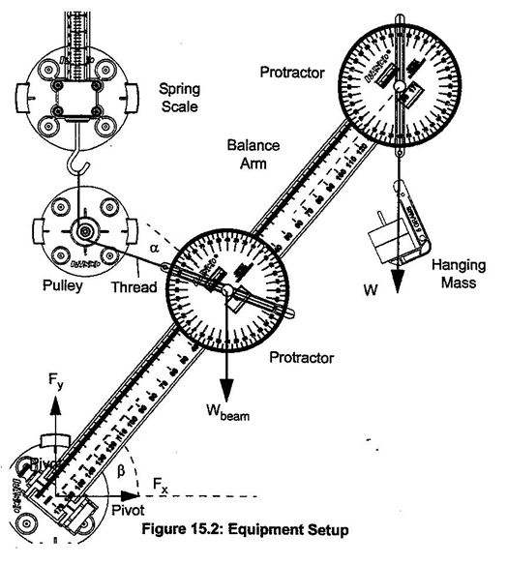
Observations: The string coming down from the spring scale had a slight angle to it in the second trial.

Data:
 |  |  | Trial 1
Length | Length _{center of mass} | α | β | Weight _{Boom} | Weight _{Mass} | T _{mathematical} | T _{Experimental}
m | m | degrees | degrees | N | N | N | N
0.32 | 0.16 | 60 | 60 | 0.6 | 0 | 0.6 | 0.6

 |  |  | Trial 2
Length | Length _{center of mass} | α | β | Weight _{Boom} | Weight _{Mass} | T _{mathematical} | T _{Experimental}
m | m | degrees | degrees | N | N | N | N
0.32 | 0.16 | 45 | 50 | 0.6 | 0.147 | 0.95 | 0.9

Analysis: The mathematical tension and the experimental tension in the first trial were exactly the same. For the second trial the two answers seem to differ slightly. This is probably due to the precision of the spring scale and not being able to read hundredths of a Newton.

