Lab 1 – LIFA and LINX Installation and 1st Circuit

Name: Lucas Bazile
Date: _____________________

The purpose of this lab is to:

Check and or install the LIFA and LINX add-ons.

Equipment needed:

1 – Arduino Uno with USB Cable
1 – Prototyping Shield
Other electronic parts and wires as needed.

Launch the VI Package Manager and verify that LIFA and LINX are installed

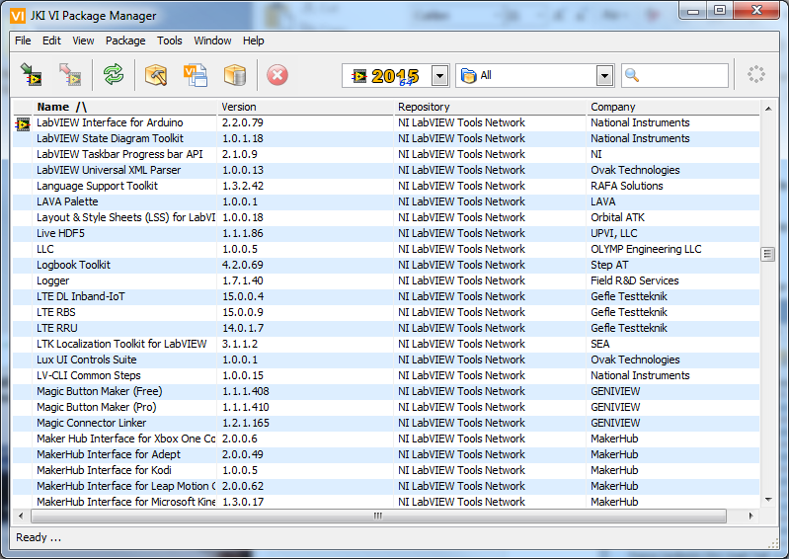
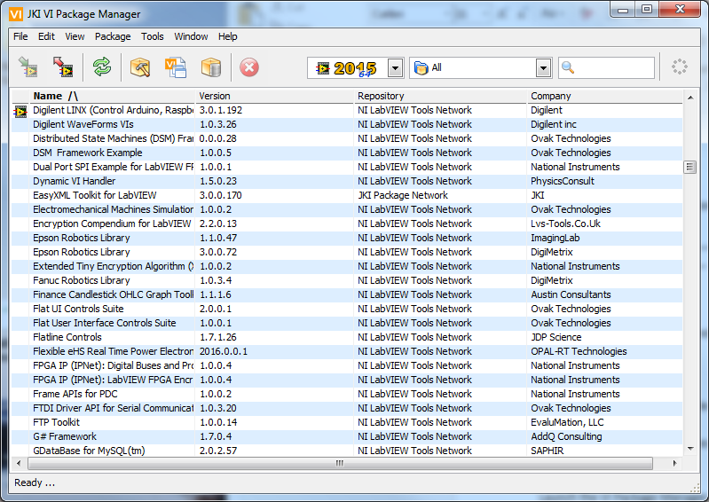

If either add-on is not installed you will need to download the add-on and attempt to install it. In some cases you may need to signup to download and install the software. Both LIFA and LINX must be installed so determine what is needed to load this software.

Please describe in detail what you needed to do to install the LIFA software:

I had to open the VI package manager and from there, I used the search box to find the LIFA package. I saw that it was not installed so I clicked install and followed the wizard. After completing the wizard it was installed with no problems.

Please describe in detail what you needed to do to install the LINX software:

This process was the same as with the LIFA package except I searched for LINX in the VI package manager.

Part 2 – Review the VIs in the LIFA and LINX add-ons and build and test a simple Example

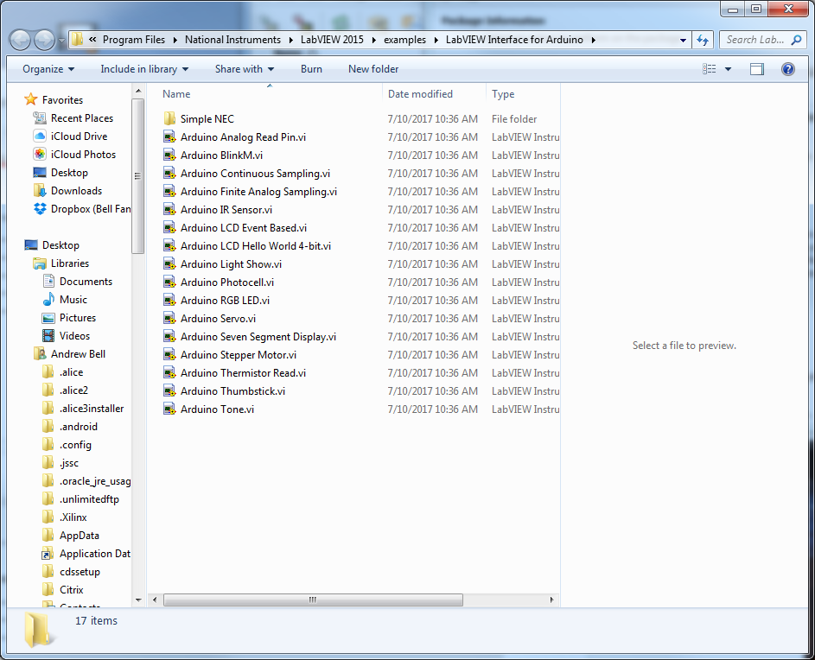

Observations:

The LINX software works fine but the LIFA software does not work properly. From what I gathered from research online everyone seems to recommend using LINX because LIFA is no longer being updated or supported.

