Lab 2 – LIFA and LINX Installation and 2nd Circuit

Name: Lucas Bazile
Date: _____________________

The purpose of this lab is to:

Check and or install the LIFA and LINX add-ons.

Equipment needed:

1 – Arduino Uno with USB Cable
1 – Prototyping Shield
Other electronic parts and wires as needed.

Review the VIs in the LIFA and LINX add-ons and build and test a simple Example

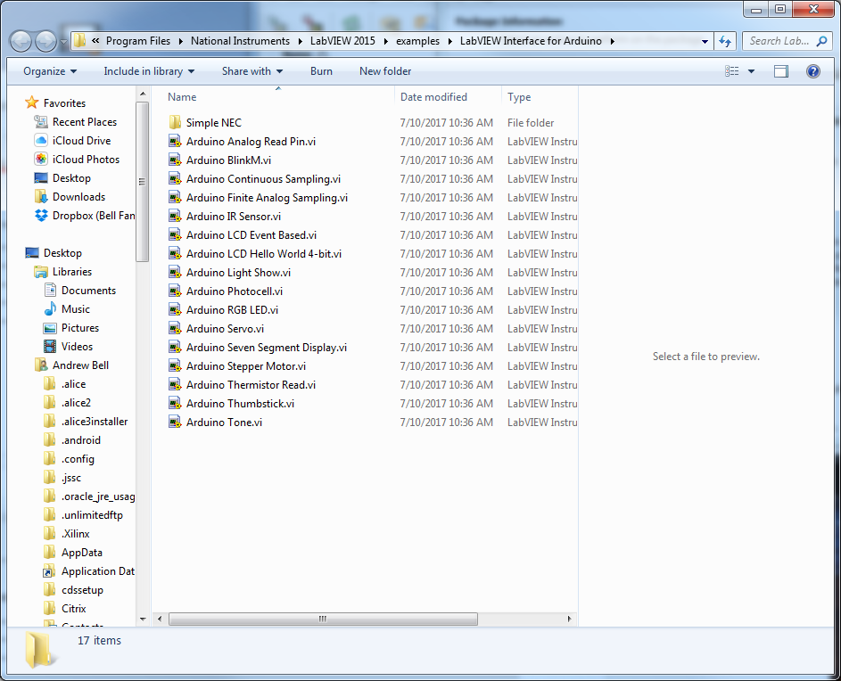

Observations: I Chose to test the photocell. LINX already had built in support for the photocell so making the circuit was fairly simple. I used an empty tank that would fill to indicate the resistance of the photocell.

